R1. What is the difference between a host and an end system? List several different
types of end systems. Is a Web server an end system?

1. There is no difference. Throughout this text, the words “host” and “end system” are used
interchangeably. End systems include PCs, workstations, Web servers, mail servers, PDAs,
Internet-connected game consoles, etc.

R4. List six access technologies. Classify each one as home access, enterprise
access, or wide-area wireless access.

4. 1. Dial-up modem over telephone line: home; 2. DSL over telephone line: home or small office;
3. Cable to HFC: home; 4. 100 Mbps switched Ethernet: enterprise; 5. Wifi (802.11): home
and enterprise: 6. 3G and 4G: wide-area wireless.

R7. What is the transmission rate of Ethernet LANs?
Ethernet LANs have transmission rates of 10 Mbps, 100 Mbps, 1 Gbps and 10 Gbps.

R9. Dial-up modems, HFC, DSL and FTTH are all used for residential access. For
each of these access technologies, provide a range of transmission rates and
comment on whether the transmission rate is shared or dedicated.

9. Dial up modems: up to 56 Kbps, bandwidth is dedicated; ADSL: up to 24 Mbps downstream
and 2.5 Mbps upstream, bandwidth is dedicated; HFC, rates up to 42.8 Mbps and upstream
rates of up to 30.7 Mbps, bandwidth is shared. FTTH: 2-10Mbps upload; 10-20 Mbps
download; bandwidth is not shared.

P2. Equation 1.1 gives a formula for the end-to-end delay of sending one packet
of length L over N links of transmission rate R. Generalize this formula for
sending P such packets back-to-back over the N links.

Problem 2
At time N*(L/R) the first packet has reached the destination, the second packet is stored
in the last router, the third packet is stored in the next-to-last router, etc. At time N*(L/R)
+ L/R, the second packet has reached the destination, the third packet is stored in the last
router, etc. Continuing with this logic, we see that at time N*(L/R) + (P-1)*(L/R) =
(N+P-1)*(L/R) all packets have reached the destination.

R24. What is an application-layer message? A transport-layer segment? A
network-layer datagram? A link-layer frame?

24. Application-layer message: data which an application wants to send and passed onto the
transport layer; transport-layer segment: generated by the transport layer and encapsulates
application-layer message with transport layer header; network-layer datagram: encapsulates
transport-layer segment with a network-layer header; link-layer frame: encapsulates network-
layer datagram with a link-layer header.

R25. Which layers in the Internet protocol stack does a router process? Which
layers does a link-layer switch process? Which layers does a host process?

25. Routers process network, link and physical layers (layers 1 through 3). (This is a little bit of a
white lie, as modern routers sometimes act as firewalls or caching components, and process
Transport layer as well.) Link layer switches process link and physical layers (layers 1
through2). Hosts process all five layers.

P6. This elementary problem begins to explore propagation delay and transmission delay, two central concepts in data networking. Consider two hosts, A and B, connected by a single link of rate R bps. Suppose that the two hosts are separated by m meters, and suppose the propagation speed along the link is s meters/sec. Host A is to send a packet of size L bits to Host B.

a. Express the propagation delay, dprop, in terms of m and s.
b. Determine the transmission time of the packet, dtrans, in terms of L and R.
c. Ignoring processing and queuing delays, obtain an expression for the end to-end delay.
d. Suppose Host A begins to transmit the packet at time t = 0. At time t = dtrans, where is the last bit of the packet?
e. Suppose dprop is greater than dtrans. At time t = dtrans, where is the first bit of the packet?
f. Suppose dprop is less than dtrans. At time t = dtrans, where is the first bit of the packet?
g. Suppose s = 2.5 10⁸, L = 1500 bytes, and R = 10 Mbps. Find the distance m so that dprop equals dtrans.

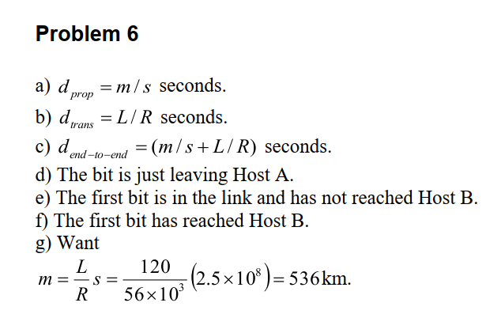

P7. In this problem, we consider sending real-time voice from Host A to Host B over a packet-switched network (VoIP). Host A converts analog voice to a digital 64 kbps bit stream on the fly. Host A then groups the bits into 56-byte packets. There is one link between Hosts A and B; its transmission rate is 10 Mbps and its propagation delay is 10 msec. As soon as Host A gathers a packet, it sends it to Host B. As soon as Host B receives an entire packet, it converts the packet’s bits to an analog signal. How much time lapses from the time a bit is created (from the original analog signal at Host A) until the bit is decoded (as part of the analog signal at Host B)?

Problem 7
Consider the first bit in a packet. Before this bit can be transmitted, all of the bits in the packet
must be generated. This requires
1 byte = 8 bit
56×8=448 bit
64 kbps=64000 bit/s
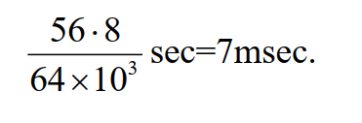 The time required to transmit the packet is
10 Mbps=10,000,000 bit/s
448/10,000,000 ​=0.0000448 s
=44.8 μs=0.0448 ms

Propagation delay = 10 msec. The delay until decoding is

7msec + 0.0448 ms + 10msec = 17. 0448 msec

P8. Suppose users share a 10 Mbps link. Also suppose each user requires 200 kbps when transmitting, but each user transmits only 10 percent of the time. (See the discussion of packet switching versus circuit switching in Section 1.3.)

a. When circuit switching is used, how many users can be supported?
b. For the remainder of this problem, suppose packet switching is used. Find he probability that a given user is transmitting.
c. Suppose there are 120 users. Find the probability that at any given time, exactly n users are transmitting simultaneously. (Hint: Use the binomial distribution.)
d. Find the probability that there are 51 or more users transmitting simultaneously.

each user requires 200 kbps
Total 10 Mbps =10000 kbps
200/10000​=50 users can be supported
p=0.1
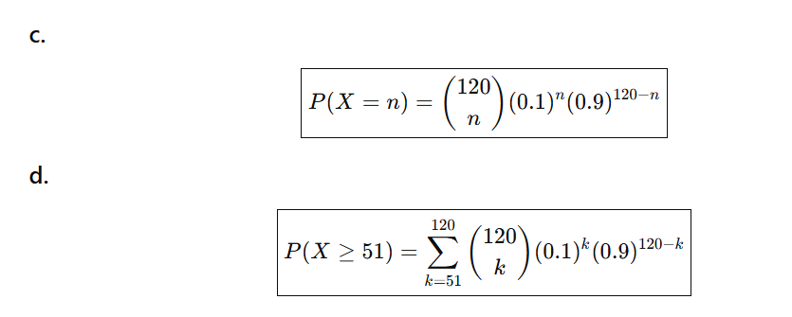
2.06×10⁻²⁰

P9. Consider the discussion in Section 1.3 of packet switching versus circuit switching in which an example is provided with a 1 Mbps link. Users are generating data at a rate of 100 kbps when busy, but are busy generating data only with probability p = 0.1. Suppose that the 1 Mbps link is replaced by a 1 Gbps link.
a. What is N, the maximum number of users that can be supported simultaneously under circuit switching?
b. Now consider packet switching and a user population of M users. Give a formula (in terms of p, M, N) for the probability that more than N users are sending data.

200 kbps
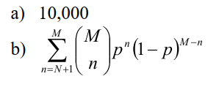

P10. Consider a packet of length L that begins at end system A and travels over three links to a destination end system. These three links are connected by two packet switches. Let di, si, and Ri denote the length, propagation speed, and the transmission rate of link i, for i = 1, 2, 3. The packet switch delays each packet by dproc. Assuming no queuing delays, in terms of di, si, Ri, (i = 1, 2, 3), and L, what is the total end-to-end delay for the packet? Suppose now the packet is 1,500 bytes, the propagation speed on all three links is
2.5 10⁸m/s, the transmission rates of all three links are 2.5 Mbps, the packet switch processing delay is 3 msec, the length of the first link is 5,000 km, the length of the second link is 4,000 km, and the length of the last link is 1,000 km. For these values, what is the end-to-end delay?

The first end system requires L/R1 to transmit the packet onto the first link; the packet propagates over the first link in d1/s1; the packet switch adds a processing delay of dproc; after receiving the entire packet, the packet switch connecting the first and the second link requires L/R2 to transmit the packet onto the second link; the packet propagates over the second link in d2/s2. Similarly, we can find the delay caused by the second switch and the third link: L/R3, dproc, and d3/s3.
Adding these five delays gives dend-end = L/R1 + L/R2 + L/R3 + d1/s1 + d2/s2 + d3/s3+ dproc+ dproc

To answer the second question, we simply plug the values into the equation to get 6 + 6 +
6 + 20+16 + 4 + 3 + 3 = 64 msec.

P13. (a) Suppose N packets arrive simultaneously to a link at which no packets are currently being transmitted or queued. Each packet is of length L and the link has transmission rate R. What is the average queuing delay for the N packets?
(b) Now suppose that N such packets arrive to the link every LN/R seconds. What is the average queuing delay of a packet?
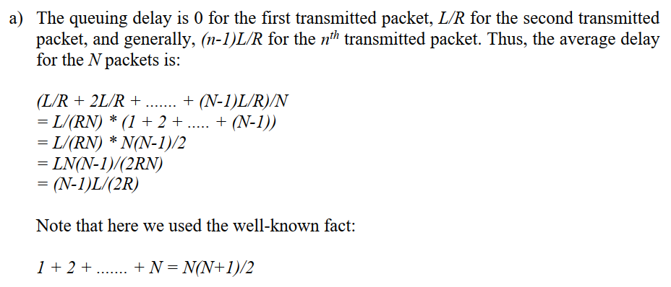
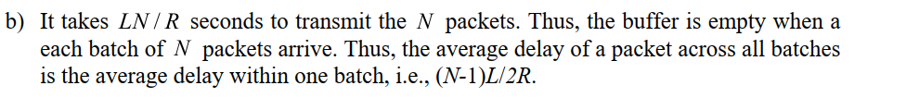

P14. Consider the queuing delay in a router buffer. Let I denote traffic intensity; that is, I = La/R. Suppose that the queuing delay takes the form IL/R (1 - I) for I 6 1.
a. Provide a formula for the total delay, that is, the queuing delay plus the transmission delay.
b. Plot the total delay as a function of L /R.
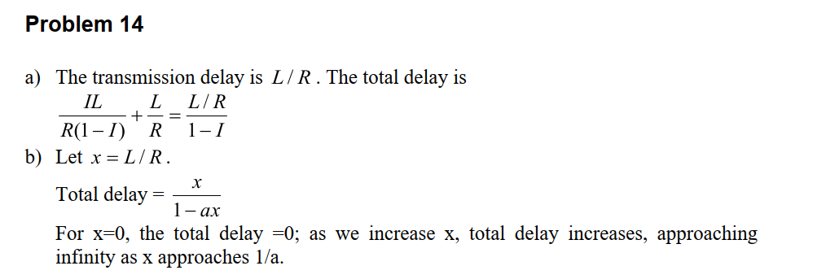

P18. Perform a Traceroute between source and destination on the same continent at three different hours of the day.
a. Find the average and standard deviation of the round-trip delays at each of the three hours.
b. Find the number of routers in the path at each of the three hours. Did the paths change during any of the hours?
c. Try to identify the number of ISP networks that the Traceroute packets pass through from source to destination. Routers with similar names and/ or similar IP addresses should be considered as part of the same ISP. In your experiments, do the largest delays occur at the peering interfaces between adjacent ISPs?
d. Repeat the above for a source and destination on different continents. Compare the intra-continent and inter-continent results.

Problem 18
On linux you can use the command
traceroute www.targethost.com
and in the Windows command prompt you can use
tracert www.targethost.com
In either case, you will get three delay measurements. For those three measurements you
can calculate the mean and standard deviation. Repeat the experiment at different times
of the day and comment on any changes.
Here is an example solution:

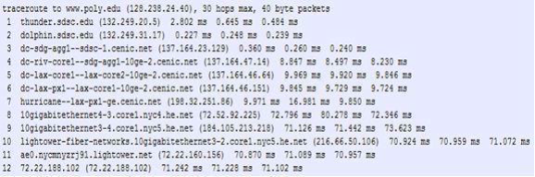
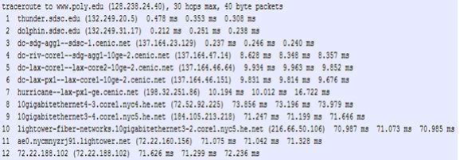
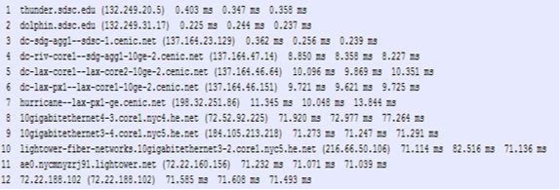
Traceroutes between San Diego Super Computer Center and www.poly.edu
a) The average (mean) of the round-trip delays at each of the three hours is 71.18 ms, 71.38 ms and 71.55 ms, respectively. The standard deviations are 0.075 ms, 0.21 ms, 0.05 ms, respectively.

b) In this example, the traceroutes have 12 routers in the path at each of the three hours. No, the paths didn’t change during any of the hours.

c) Traceroute packets passed through four ISP networks from source to destination. Yes, in this experiment the largest delays occurred at peering interfaces between adjacent ISPs.

P25. Suppose two hosts, A and B, are separated by 20,000 kilometers and are con-
nected by a direct link of R = 5 Mbps. Suppose the propagation speed over
the link is 2.5 # 108 meters/sec.
a. Calculate the bandwidth-delay product, R # dprop.
b. Consider sending a file of 800,000 bits from Host A to Host B. Suppose the file is sent continuously as one large message. What is the maximum number of bits that will be in the link at any given time?
c. Provide an interpretation of the bandwidth-delay product.
d. What is the width (in meters) of a bit in the link? Is it longer than a football field?
e. Derive a general expression for the width of a bit in terms of the propagation speed s, the transmission rate R, and the length of the
link m.

Problem 25
a) 160,000 bits
b) 160,000 bits
c) The bandwidth-delay product of a link is the maximum number of bits that can be in the link.
d) the width of a bit = length of link / bandwidth-delay product, so 1 bit is 125 meters long, which is longer than a football field
e) s/R

P26. Referring to problem P24, suppose we can modify R. For what value of R is the width of a bit as long as the length of the link?

s/R=20000km, then R=s/20000km= 2.5*108/(2*107)= 12.5 bps

P27. Consider problem P24 but now with a link of R = 500 Mbps.
a. Calculate the bandwidth-delay product, R # dprop.
b. Consider sending a file of 800,000 bits from Host A to Host B. Suppose the file is sent continuously as one big message. What is the maximum number of bits that will be in the link at any given time?
c. What is the width (in meters) of a bit in the link?

a) 80,000,000 bits
b) 800,000 bits, this is because that the maximum number of bits that will be in the link
at any given time = min(bandwidth delay product, packet size) = 800,000 bits.
c) .25 meters

P28. Refer again to problem P24.
a. How long does it take to send the file, assuming it is sent continuously?
b. Suppose now the file is broken up into 20 packets with each packet containing 40,000 bits. Suppose that each packet is acknowledged by the receiver and the transmission time of an acknowledgment packet is negligible. Finally, assume that the sender cannot send a packet until the preceding one is acknowledged. How long does it take to send the file?
c. Compare the results from (a) and (b).

Problem 28
a) ttrans + tprop = 400 msec + 80 msec = 480 msec.
b) 20 * (ttrans + 2 tprop) = 20*(20 msec + 80 msec) = 2 sec.
c) Breaking up a file takes longer to transmit because each data packet and its corresponding acknowledgement packet add their own propagation delays.

P29. Suppose there is a 10 Mbps microwave link between a geostationary satellite and its base station on Earth. Every minute the satellite takes a digital photo and sends it to the base station. Assume a propagation speed of 2.4 # 108 meters/sec.
a. What is the propagation delay of the link?
b. What is the bandwidth-delay product, R # dprop?
c. Let x denote the size of the photo. What is the minimum value of x for the microwave link to be continuously transmitting?
Problem 29

Recall geostationary satellite is 36,000 kilometers away from earth surface.
a) 150 msec
b) 1,500,000 bits
c) 600,000,000 bits

P31. In modern packet-switched networks, including the Internet, the source host segments long, application-layer messages (for example, an image or a music file) into smaller packets and sends the packets into the network. The receiver then reassembles the packets back into the original message. We refer to this process as message segmentation. Figure 1.27 illustrates the end-to-end transport of a message with and without message segmentation. Consider a message that is 10⁶ bits long that is to be sent from source to destination in Figure 1.27. Suppose each link in the figure is 5 Mbps. Ignore propagation, queuing, and processing delays.
a. Consider sending the message from source to destination without message segmentation. How long does it take to move the message from the source host to the first packet switch? Keeping in mind that each switch uses store-and-forward packet switching, what is the total time to move the message from source host to destination host?
b. Now suppose that the message is segmented into 100 packets, with each packet being 10,000 bits long. How long does it take to move the first packet from source host to the first switch? When the first packet is being sent from the first switch to the second switch, the second packet is being sent from the source host to the first switch. At what time will the second packet be fully received at the first switch?
c. How long does it take to move the file from source host to destination host when message segmentation is used? Compare this result with your answer in part (a) and comment.
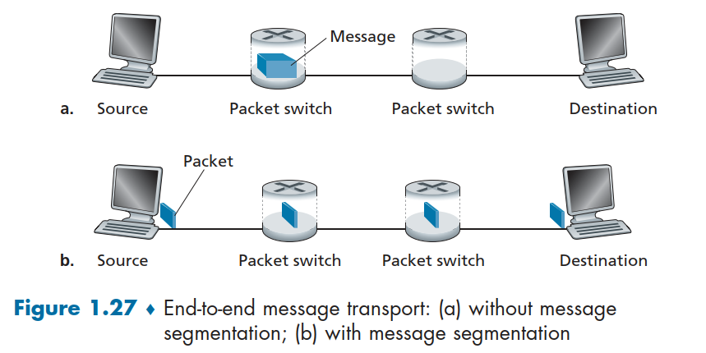
d. In addition to reducing delay, what are reasons to use message segmentation?
e. Discuss the drawbacks of message segmentation.

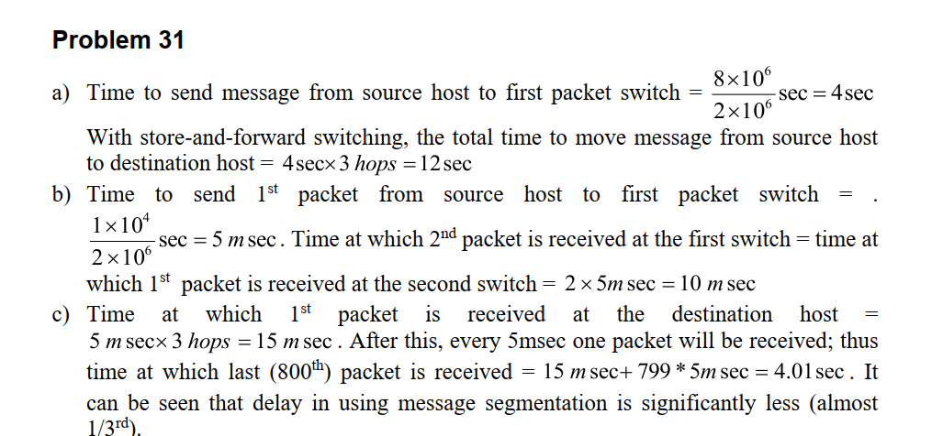

d) i. Without message segmentation, if bit errors are not tolerated, if there is a single bit error, the whole message has to be retransmitted (rather than a single packet).
ii. Without message segmentation, huge packets (containing HD videos, for example) are sent into the network. Routers have to accommodate these huge packets. Smaller packets have to queue behind enormous packets and suffer
unfair delays.

e) i. Packets have to be put in sequence at the destination.
ii. Message segmentation results in many smaller packets. Since header size is usually the same for all packets regardless of their size, with message segmentation the total amount of header bytes is more.

